Press release
CBRE: +421 232 553 300
Cushman & Wakefield: +421 259 209 333
Colliers: +421 259 980 980
JLL: +421 259 209 931

October 21st 2021, Bratislava

Bratislava Research Forum Announces

Office Market Figures for Q3 2021

In the third quarter of 2021, the total office stock in Bratislava reached more than 1.975 million sqm. 64% of total stock consists of class A office space and 36% of class B office space.

During the third quarter of 2021, two new office buildings were added to the market, namely Jurkovicova Teplaren (with 4,206 sqm) and Klingerka Office (with 10,500 sqm), together adding almost 15,000 sqm to the stock. There are 2 other projects awaiting to be introduced to the market in 2021, with the total gross leasable area of 27,000 sqm, both in A class category.

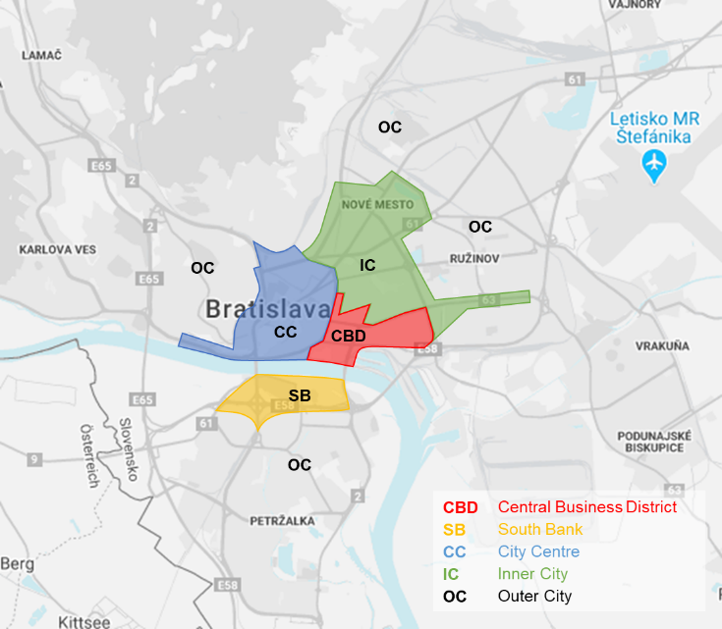

In terms of the ownership structure, similarly to the previous quarter, approximately 4% of the office stock is state-owned, 13% are buildings owned and fully occupied by the same entity, and the total stock for commercial use remains at 83% (or around 1.6 million sq m) of total modern office stock in Bratislava.

Green Certified Buildings

In total, Bratislava offers up to 672,734 sqm of office space with a valid green / sustainable building certificate. This is 34% of the total volume of office space in Bratislava, or 35 out of 294 buildings. 62% of the certified stock has BREEAM, 4% combination of BREEAM / WELL GOLD and 34% LEED certificate. Only the Twin City Tower has the highest BREEAM Outstanding rating, and in the case of LEED Platinum, the Digital Park buildings and Ein Park Offices are its only current holders. Klingerka Office reached BREEAM EXCELLENT certification in Q3.

Office Market Transactions (Take-Up)

Lease transactions in the third quarter of 2021 reached a total area of approx. 44,000 sqm, which represents almost 20% decrease in leasing activity compared to the same quarter last year. New leases accounted for 45% of the total take up, renegotiations 37%, lease-expansions 7 %, while the remaining 11% were pre-leases.

The largest transaction this quarter is a pre-lease contract in the customer goods sector with an area of 5,000 square meters, but we also record another 10 transactions with an individual area exceeding 1,000 sq m.
The majority of leased space this quarter was leased within the professional services sector (23 %), the customer goods sector (21 %) and the public sector (18%). It is worth mentioning the comparison of the first three quarters in 2020 and 2021, where we record a 27% increase in total leasing activity (office take-up), while newly leased areas (total rent activity without renegotiations) recorded an increase of up to 79%.

Significant Office Transactions in Q3

Property | Let area (sq m) | Occupation | Type of deal
BBC 6 (The Mill) | 5,000 | Consumer goods | Pre-lease
Jurkovicova Teplaren | 3,540 | Professional services | New lease
Plus Centrum I | 3,300 | Public | New lease
Digital Park II+III | 2,900 | Professional services | Renegotiation
Eurovea Central | 2,300 | Professional services | Renegotiation
Pradiaren 1900 | 1,541 | Finance/Banking/  Insurance | New lease
Park One | 1,527 | Public | Lease- expansion
City Business Center I | 1,390 | Pharma/Medical | Renegotiation
CEOP | 1,140 | Professional services | Renegotiation
Rosum | 1,075 | Pharma/Medical | Renegotiation

Office Vacancy

The overall vacancy rate in Bratislava decreased to 12.21% from 12.22% in the previous quarter. The lowest vacancy rate was recorded in the City Centre submarket (6.57%), followed by the Inner City (10.21%), Outer City (13.64%), CBD (15.46%) and South Bank, recording the highest vacancy rate of 16.76%. The net absorption increased solidly by more than 13,000 sqm.

Prime Rent

Prime rent remained unchanged at 16.50 EUR / m2 / month compared to the previous quarter.

For further information please contact any member of the Bratislava Research Forum.

Definitions

Stock: Total completed office space (occupied and vacant), newly built since 1993 or refurbished, A and B class offices, owner occupied and for lease.

New supply: Completed newly built or refurbished buildings that obtained a use permit in the given period.
A-Class office building: Reflects an above average fullfilment of the specific criteria including the following: integrated air conditioning system, limited total floor depth, floor to ceiling height minimum of 2.75m, flexibility of internal design, either three compartment trunking for telephones, electricity and computer cable or raised floors/suspended ceilings, manned reception and covered access to car parking, lift access and disabled access, dual power supply and/or power supply system back-up.

B-Class office building: Reflects an average or typical property in that market based on the above mentioned criteria.

Take-up: A gross figure representing the total floor space known to have been let or pre-let, sold or pre-sold to tenants or owner-occupiers over a specified period of time. It does not include space that is under offer. A property is taken up when the contract is signed. Total take-up includes re-negotiations, net take-up excludes re-negotiations.

Pre-lease: Active pre-leasing for an office building begins as soon as preliminary design drawings are ready to show to prospective tenants. Pre-leasing occurs until the start of construction.

Vacancy rate: Ratio of physically vacant space in completed buildings as a percentage of the total stock.
Prime rent: Achieved rents that relate to new prime, high specification units in prime locations.

COPYRIGHT © Bratislava Research Forum 2021

This publication is the sole property of the Bratislava Research Forum, (Members: Cushman and Wakefield, CBRE, Colliers International and Jones Lang LaSalle) and must not be copied, reproduced or transmitted in any form or by any means, either in whole or in part, without the prior written consent of the Bratislava Research Forum. The information contained in this publication has been obtained from sources generally regarded to be reliable. However, no representation is made, or warranty given, in respect of the accuracy of this information. We would like to be informed of any inaccuracies so that we may correct them. The Bratislava Research Forum, does not accept any liability in negligence or otherwise for any loss or damage suffered by any party resulting from reliance on this publication.

