Press release
CBRE: +421 232 553 300
Cushman & Wakefield: +421 259 209 333
Colliers: +421 259 980 980
JLL: +421 259 209 931

April 28th 2022, Bratislava

Bratislava Research Forum Announces

Office Market Figures for Q1 2022

In the first quarter of 2022, the total office stock in Bratislava surpassed 2 million sqm for the first time and reached the value of 2.005 million sqm. 65% of total stock consists of class A office space and 35% of class B office space.

During the first quarter of 2022, one new office building was added to the market, namely Omnia BC with 11,160 sqm.

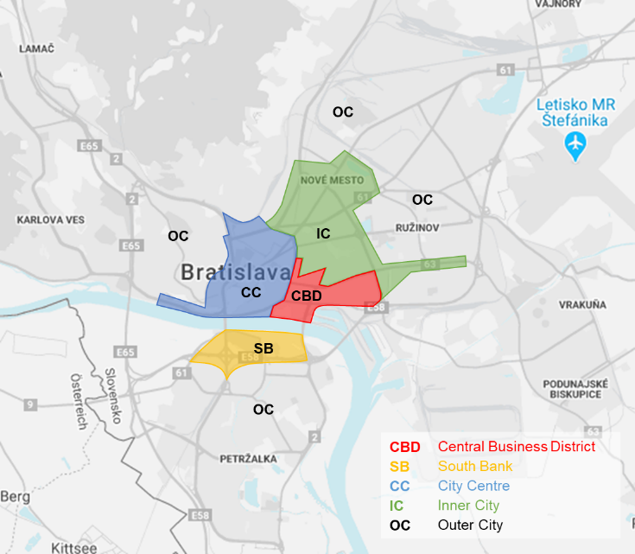

In terms of the ownership structure, similarly to the previous quarter, approximately 4% of the office stock is state-owned, 12% are buildings owned and fully occupied by the same entity, and the total stock for commercial use remains at 84% (or around 1.68 million sq m) of total modern office stock in Bratislava.

Green Certified Buildings

In total, Bratislava offers almost 645,300 sqm of office space with a valid green / sustainable building certificate. This is 32% of the total volume of office space in Bratislava, or 37 out of 299 buildings. 63% of the certified stock has BREEAM, 5% combination of BREEAM / WELL GOLD and 32 % LEED certificate. Only the Twin City Tower has the highest BREEAM Outstanding rating, and in the case of LEED Platinum, the Digital Park buildings and Ein Park Offices are its only current holders.

Office Market Transactions (Take-Up)

Lease transactions in the first quarter of 2022 reached a total area of approx. 42,900 sqm, which represents 56% decrease in leasing activity compared to the previous quarter. In a year-on-year comparison, the number of leased areas decreased by 27%. New leases accounted for 70% of the total take up, renegotiations 17%, lease expansion 11%, while the remaining 2% were lease leases.

Take-up was dominated by transactions in the IT sector with size of 11,170 m2. The largest transaction was in the public sector with amount of 5,000 m2. A total of 9 transactions were recorder with an area of over 1,000 m2.
The majority of leased space this quarter was leased within the IT (26%), finance sector (22%) and professional services (20%).

Significant Office Transactions in Q4

Office building | Lease area (sqm) | Sector | Type of transaction
Omnia BC | 5,000 | Public sector | new lease
Panorama Business 2 | 4,811 | Finance/Banking/Insurance | new lease
Digital Park II+III | 2,330 | IT | expansion
Ein Park Offices | 1,671 | IT | new lease
Pradiareň 1900 | 1,380 | Other | new lease
GBC V | 1,200 | Consumer goods | new lease
GBC V | 1,200 | Professional services | new lease
Nivy Tower | 1,190 | IT | new lease
myhive Vajnorská/Tower 1 | 1,080 | IT | renegotiation
City Business Center II | 972 | Finance/Banking/Insurance | new lease

Office Vacancy

The overall vacancy rate in Bratislava slightly increased compared to previous quarter by 0,13 % to current 11.83%. The lowest vacancy rate was recorded in the City Centre submarket (7.07%), followed by the Inner City (9.50%), CBD (13.86%), Outer City (14.63%) and South Bank, recording the highest vacancy rate of 15.91%.

Prime Rent

Prime rent remained unchanged at 16.50 EUR / m2 / month compared to the previous quarter.

For further information please contact any member of the Bratislava Research Forum.

Definitions

Stock: Total completed office space (occupied and vacant), newly built since 1993 or refurbished, A and B class offices, owner occupied and for lease.

New supply: Completed newly built or refurbished buildings that obtained a use permit in the given period.
A-Class office building: Reflects an above average fullfilment of the specific criteria including the following: integrated air conditioning system, limited total floor depth, floor to ceiling height minimum of 2.75m, flexibility of internal design, either three compartment trunking for telephones, electricity and computer cable or raised floors/suspended ceilings, manned reception and covered access to car parking, lift access and disabled access, dual power supply and/or power supply system back-up.

B-Class office building: Reflects an average or typical property in that market based on the above mentioned criteria.

Take-up: A gross figure representing the total floor space known to have been let or pre-let, sold or pre-sold to tenants or owner-occupiers over a specified period of time. It does not include space that is under offer. A property is taken up when the contract is signed. Total take-up includes re-negotiations, net take-up excludes re-negotiations.

Pre-lease: Active pre-leasing for an office building begins as soon as preliminary design drawings are ready to show to prospective tenants. Pre-leasing occurs until the start of construction.

Vacancy rate: Ratio of physically vacant space in completed buildings as a percentage of the total stock.
Prime rent: Achieved rents that relate to new prime, high specification units in prime locations.

COPYRIGHT © Bratislava Research Forum 2022

This publication is the sole property of the Bratislava Research Forum, (Members: Cushman and Wakefield, CBRE, Colliers International and Jones Lang LaSalle) and must not be copied, reproduced or transmitted in any form or by any means, either in whole or in part, without the prior written consent of the Bratislava Research Forum. The information contained in this publication has been obtained from sources generally regarded to be reliable. However, no representation is made, or warranty given, in respect of the accuracy of this information. We would like to be informed of any inaccuracies so that we may correct them. The Bratislava Research Forum, does not accept any liability in negligence or otherwise for any loss or damage suffered by any party resulting from reliance on this publication.

